

**Phase 3 Investment Case**

# Table of Contents

Table of Contents 2

1. Document Information 2

1.1 Change History 3

1.2 Sign-off 3

1.3 Referenced or related documents 3

2 Planning – checklist 4

1 Introduction 6

1.1 Executive Summary 6

1.2 Background 6

1.2.1 Previous Baselines 6

2 Strategy 8

2.1 CoreMod Alignment to Kiwibank Strategy and Objectives 8

2.1.1 Digital Bank Alignment 8

2.2 Technology Roadmap 8

3 Options 9

3.1 Scope Options 9

3.2 Implementation Options 9

4 Scope, Timeline and Risks 10

4.1 Progress so far 10

4.2 Key Conclusions to date 10

4.3 Programme Timeline 10

4.4 External Dependencies 10

5 Planning Approach 11

6 Implementation Planning 12

7 Financial Planning 12

8 Benefits Planning 12

9 Risk Planning 12

9.1 Strategic Risks 12

9.2 Delivery Risks 12

9.3 Financial Risks 13

10 Programme Governance 13

## Document Information

## Change History

| Version | Date | Name | Brief outline of changes |
| --- | --- | --- | --- |
| 0.1 | **14/09/2015** | **Stuart MacDonald** | Initial layout |
|  |  |  |  |
|  |  |  |  |

## Sign-off

|  |  |  |  |  |
| --- | --- | --- | --- | --- |
| Type | Name | Title | Signature | Date |
| Governance | Board |  | [Approved evidence in Board minutes - DATE] |  |
| Governance | Steering Committee |  | [Endorsed through Steering Committee minutes - DATE] |  |
| Accountable | Nick Astwick | Programme Sponsor | [Endorsed through Sponsor cabinet minutes - DATE] |  |
| Responsible | Phil Parker | Programme Director |  |  |
| Responsible | Brent Healy | Financial Controller |  |  |

## Referenced or related documents

|  |  |  |  |
| --- | --- | --- | --- |
| Title | Link | Version | Date |
| December 2013 Business Case |  |  |  |
| December 2014 Business Case |  |  |  |
| May 2015 Implementation Case |  |  |  |
|  |  |  |  |

# Planning – checklist

To be removed on completion of the document

Narrative to cover

1. Ready for review by 3rd November (Steer Co 9 Nov)
2. Past 🡪 current state 🡪 planned future state
   1. **Provide a narrative from original business case “**Genesis of CoreMod”
      1. **Benefits committed to, current state of achieving the benefits “**Progress so far”
   2. **Provide current state “**Progress so far”
      1. **Comparative of key baselines changes to costs “Previous Baselines**”
      2. **Current ETC and schedule for completing the programme** **“**Progress so far”
      3. **Learnings on the programme and how the learnings are incorporated into Phase 3 (nice-to-have?) “Key conclusions to date”**
      4. **Discussion on Enterprise level objectives and how this investment case gives an opportunity to confirm/adjust alignment**
         1. **Digital Bank**
         2. **Technology Target Roadmap**
            1. **Options present different transitional roadmaps taking different benefits. Some take us further towards the Kiwibank target state.**
   3. Future state
      1. What the options are for the future state
         1. Readiness assessment against options
            1. Risk profile and associated contingency requirement
            2. Cost profile
            3. View of schedule
      2. Expected costs to reaching the future state
3. Make it very clear on options and decisions to be made (should be in the supporting decisions paper)
4. Planning approach
   1. Differences of the investment case and the implementation case
   2. Road to investment case with constraints noted
   3. Road to implementation case and what the confidence is on meeting a May timeline
5. Estimates
   1. Short overview on the estimation approach and how variability on the estimates will exist until requirements. Design and blueprinting is completed
   2. Preferred contingency required per option (based on risk)
6. Costs – make sure we have accounted for:
   1. 2/ SAP related costs for Phase 2 – make sure we check SAP costs are fully accounted (including Max attention considerations)

**Key Messages / concepts**

“Provide a reliable and stable Core banking platform for growth in new banking services, products and markets”

Long journey and large scope

This is big

Spend to remove complexity

Simplification

Regretful spend

**Inputs required for Investment Case**

**Inputs required for** **BASE CASE** **estimations and investment case**

1. Sizing - Scoping document (architecture document)
   1. Benefits and Business functional scope – option 1
   2. Empty Ultracs
   3. Decommission Ultracs
      1. Historical data – guidance on scope of data for cleanse and migration
   4. Process catalogue (used mainly for scope gap validations and ensuring correct actors/stakeholders are involved)
   5. Current design patterns to be stated – baseline assumption for estimate
      1. As a principle current P1 & P2 integration patterns continue
      2. As a principle – Back office use blue screens or In touch development?
      3. Etc.
2. High Level Solution Architecture Design – option 1
   1. Informs licensing, sizing, and migration options
   2. Informs functional domains and guides PBS/WBS formation
3. Estimation Planning
   1. WBS/PBS
   2. Sequencing and (modelled) schedule (to enable schedule view to account for programme overhead)
   3. Estimation approach per WBS/PBS item

**Inputs required for options based scope estimations and investment case**

1. Sizing - Scoping document
2. Benefits and Business functional scope – option 2, 3, 4
3. Empty Ultracs
4. Decommission Ultracs
   1. Historical data – guidance on scope of data for cleanse and migration
5. Process catalogue (used mainly for scope gap validations and ensuring correct actors/stakeholders are involved)
6. Alternative design patterns
   1. Integration layer pattern defined and service calls, channel screens and business logic impacted (assumption based acceptable if the correct SME is making the assumptions and the assumptions are clearly stated)
   2. SAP Blue screen vs. UI5 vs. In-touch design decisions for exposing functionality. Back office / front office impact guidance
7. High Level Solution Architecture Design – option 2, 3, 4
   1. Informs licensing, sizing, and migration options
   2. Informs functional domains and guides PBS/WBS formation
8. Estimation Planning
   1. WBS/PBS
   2. Sequencing and (modelled) schedule (to enable schedule view to account for programme overhead)
   3. Estimation approach per WBS/PBS item

# Introduction

2 pg max

## Executive Summary

Checklist:

1. Summarises options, costs, completion date and key benefits

Quality Criteria:

Must provide clear purpose for the Investment case

1. Why is it being presented
2. What decision and guidance is required
3. Make sure it is noted when the programme is coming back with the implementation case

The purpose of this Investment Case is to provide the Management Committee and Board an analysis on the cost, benefits, risks and options for completing the Core Modernisation Programme. This paper provides the Management Committee and Board background information required to make investment decisions across the Core Modernisation Phase 3 benefits and delivery options.

This investment case is to inform the Management Committee and Board for decisions on:

1. Selection of programme options on benefits and scope

* Validate alignment to the current Kiwibank Strategic Objectives
* Approve funds for completion of blueprinting (requirements, design and planning)

1. Approve funds for completion of requirements, design and planning

## Background

[Can largely reuse from past business cases]

Checklist

1. Impetus for the programme
2. Organisation readiness and constraints
3. Ramp-off points and current view of ramp-off points
4. Previous baselines
5. Noting any movement from original business case perspective

Quality Criteria:

Must provide historical background

Must provide current view of impetus for programme (business case can pivot)

Must provide a view on current organisation readiness and constraints

### Previous Baselines

[The previous baselines provide a starting point for viewing the Phase 3 investment case]

Checklist

1. Comparative of key baselines changes to costs

Quality Criteria

1. Should provide analysis on why the baselined changed

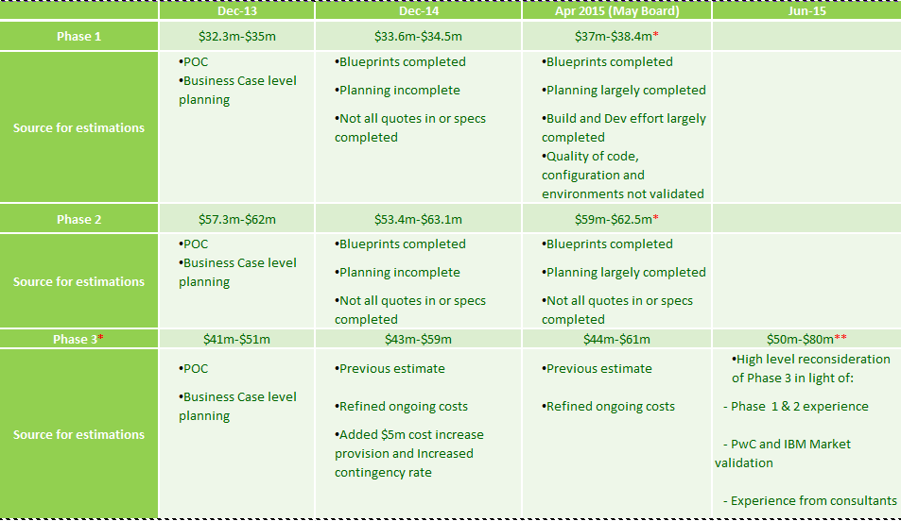

* Phase 3 includes the original Phase 2.3

** Phase 1 looks on track (within tolerances). At the moment, Phase 2 estimated cost to completion is within tolerance

*** Phase 3 estimate adjusted in the Jun 15 Board paper, but KB Business Plan reflects Apr 15 numbers

# Strategy

2-3 pages

[This should be noted as CoreMod Strategy and how it works within KB strategy

Can largely reuse from the original business case and current CTO artefacts

For flow of the document there should still be some language on delivery risk as a lead on to the next section (not to be 100% siloed discussion into only strategy and vision)]

Checklist

1. Discussion on Enterprise level objectives and how this investment case gives an opportunity to confirm/adjust alignment
2. Vision statement and narrative
3. View of Technology and capabilities roadmap and where CoreMod Phase 3 is as a transition state – this should be shown per option (assuming options are different and not just minor derivations from each other).
   1. Regretful spend concept
4. Enabler discussion
5. Strategy to deal with constraints (fiscal and resource) leading to a limitations to change all channels etc.
6. Design/Enterprise Architecture Principles (noting potential conflicts and how some principles are constrained by fiscal and resource constraints)
7. Delivery Principles should also be noted in this section
8. Alignment to Digital Programme

Quality Criteria:

1. Must be easy to understand for the audience, but the concepts should not be dumbed down
2. Must be balanced in regards to a strategy that is fiscally feasible for KB
3. Must show a balanced non-conflicting approach to incorporating the Design principles (also must be re-usable for people writing blueprints)
4. Must give the strategy for removing Ultracs from the environment (especially if we are changing the baseline scope from the original business case which mandates removing Ultracs as scope)
5. Must be easy to understand what has changed from the original previous baselined noted strategies
6. Any significantly different options being presented must be treated first class (try not to fall into the trap of only showing a view of something across the recommended option)
7. Near the end of the section have some language on delivery risk needing to be managed (this is to temper the vision and also help to lead onto the next section of the document which is focused around programme management and achieving delivery

## CoreMod Alignment to Kiwibank Strategy and Objectives

### Digital Bank Alignment

## Technology Roadmap

# Options

2 pages

[This section is to provide the options to deliver the CoreMod programme

To include:

1. Scope options
2. Implementation Options
3. Recommended option under constraints and Enterprise and Delivery principles consideration]

Checklist

1. Option selection drivers clear
2. Options that change and/or cover the business case scope
3. Options defined in context of
   1. benefits and capabilities enabled or realised
   2. Target state (technology and capabilities roadmap)
4. Options in context to alignment Digital
5. Ensure the size of the work is well understood
6. Ensure a view of complexity to deliver and complexity left is clear
7. Make it clear what is in and out-of-scope (benefits, capabilities and space junk removed)

Quality Criteria:

1. Must be easy to understand for the audience, but the concepts should not be dumbed down
2. Must be balanced in regards to a strategy that is fiscally feasible for KB
3. Ensure the size of the work is well understood
4. Ensure a view of complexity to deliver and complexity left is clear
5. Must be clear what is in and out-of-scope (benefits, capabilities and space junk removed)
6. Provide a view to compare options

## Scope Options

## Implementation Options

# Scope, Timeline and Risks

3 pages

[This section is to the cover the programme management delivery aspects of the programme

Focusing on Scope, timeline and risks]

Checklist

1. Try to keep business context
2. Ensure the size of the work is well understood
3. Make it clear what is in and out-of-scope
4. Provide a view of what is in scope but not sized to +/-30% yet
5. Reference appendix items to show that bottom-up planning is in place for $$ approval being requested re. completion of blueprinting (and planning)
6. Highlight delivery risk along with how managing scope and complexity is the surest way to reduce delivery risk

Quality Criteria:

1. Must be easy to understand for the audience, but the concepts should not be dumbed down
2. Must be balanced in regards to a strategy that is fiscally feasible for KB
3. [more to come]

## Progress so far

Checklist:

1. Provide current state
2. Current ETC and schedule for completing the programme

## Key Conclusions to date

Checklist:

1. Learnings on the programme and how the learnings are incorporated into Phase 3 (nice-to-have?)

## Programme Timeline

Checklist:

1. Overlay Phases 1 - 3

## External Dependencies

Checklist:

1. Only include materials dependencies that exist and are required to deliver Phase 3

# Planning Approach

½ - 1 page

[Provides a short view across the ASAP8 lifecycle and exit criteria for planning (as a way to summarise key elements required to complete planning). Provide an upfront view if a dev-to-schedule planning approach is to be used or whether it is fully locked and loaded

Checklist

1. Explain the different between the investment case and implementation case
2. Show how the Phase 3 will have projects will be arranged to be small in size (delivering capabilities) and the benefits they will be able to offer (allows more flexibility in changing scope and implementation approach and naturally leads to a desired modular design (Conways law). It would make more sense to have more than 1 tranch in Phase 3 – achieved through smaller projects
3. Explain what the estimation approach has been, what variance this has lead to
4. Explan what the estimation approach when the blueprinting is completed
5. Give a reality check that >15% (we need a real reference) of a budget is normally spent on requirements, design and planning – and therefore for the size of work being looked at and the resources available a staggered approach to blueprinting will be required to meet April/May for the implementation case
6. Note that estimates are targets not predictions and that the estimates will change by the time the implementation case is completed

Quality Criteria:

1. Must be easy to understand for the audience, but the concepts should not be dumbed down
2. Must be balanced in regards to a strategy that is fiscally feasible for KB
3. [more to come]

The programme is working towards a December milestone to provide an assessment of high-level costs for the programme which will be broken down across components, benefits and approaches

# Implementation Planning

3 pg

[Provides a deeper view across the approaches to implementing the Programme. Provides a view across trade offs across risk, constraints, business benefits timing]

Quality Criteria:

1 pg

1. Recommended implementation approach should score higher in the trade-offs
2. Must be balanced in regards to a strategy that is fiscally feasible for KB

# Financial Planning

[Provides views across financials to each of the options]

Quality Criteria:

1. Per option includes fiscal year timeline CAPEX/OPEX breakdowns
2. Per option includes view across the programme cost – not just Phase 3 cost
3. Per option includes a view on ROI (IRR, cost of capital etc.)
4. Per option risk contingency required

# Benefits Planning

3 pg

[Provides detail on the benefits enabled and realised across each of the options. Includes disbenefits per option]

Quality Criteria:

1. Include material disbenefits inherent with options (complexity / operational risk of dual core as an example)
2. Include detail on benefits benefits map

# Risk Planning

2 pg

[Provides detail on the risks across each of the options.]

Quality Criteria:

1. Allow for comparison through some level of quantification
2. Ensure the risk levels per option align with the contingency requirements noted

## Strategic Risks

## Delivery Risks

## Financial Risks

# Programme Governance

1 pg

[Provides detail on the risks across each of the options.]

Checklist

1. Explain the different between the investment case and implementation case
2. Show how the Phase 3 will have projects will be arranged to be small in size (delivering capabilities) and the benefits they will be able to offer (allows more flexibility in changing scope and implementation approach and naturally leads to a desired modular design (Conways law). It would make more sense to have more than 1 tranch in Phase 3 – achieved through smaller projects
3. Explain what the estimation approach has been, what variance this has lead to
4. Explan what the estimation approach when the blueprinting is completed
5. Give a reality check that >15% (we need a real reference) of a budget is normally spent on requirements, design and planning – and therefore for the size of work being looked at and the resources available a staggered approach to blueprinting will be required to meet April/May for the implementation case